**TAB-2-MusicXML™ (T.2.M)**

**User Manual**

***V2 - February 26***

**By EECS2311 Team 4**

* Patchanon Suepai
* Suha Siddiqui
* Nobaiha Zaman Rayta
* Zhilong Lin
* Martin Brejniak

Table Of Contents

**1. Introduction** **3**

**2. Contact Details** **3**

**3. Product Name** **3**

**4. Model Number** **3**

**5. Features/Accessories** **3**

5.1) User capabilities 3

5.1.a) Currently implemented features 3

5.1.b) Upcoming features 4

5.2) Automatic (potential) features 4

**6. Usage Scenarios** **5**

6.1) A person pastes a tablature into the program: 5

6.2) A person uploads a tablature into the program: 6

**7. Getting Started** **6**

**8. Installation Instructions** **6**

**9. Usage Instructions** **6**

**10. Sample Input Tablature** **12**

**11. Troubleshooting** **12**

11.1) Error screen related issues 12

11.2) Input related issues 13

**12. Maintenance Information** **13**

**13. Uninstallation Instructions** **13**

**14. Technical Specifications** **13**

# 1. Introduction

The TAB-2-MusicXML™ (T.2.M) converter takes the tablatures of guitar (and eventually percussion) music, and converts them into a musicXML file. This user manual will go over how to install the current version of the T.2.M and how to use it.

# 2. Contact Details

If you have any further questions or concerns, please feel free to reach out to us through our email ([EECS2311Team4@gmail.com](mailto:EECS2311Team4@gmail.com)).

# 3. Product Name

TAB-2-MusicXML™

# 4. Model Number

Version 2.0

# 5. Features/Accessories

## 5.1) User capabilities

### 5.1.a) Currently implemented features

* + - Uploading the input text file (tablature) for guitar tablatures (Percussion and bass coming soon).
    - Ability to paste guitar tablatures for conversion.
    - Able to save final XML output code.

### 5.1.b) Upcoming features

* + - Can input the title, composer, tempo, appropriate harmonics, key, etc. (components that are not typically present on tab) can be manually entered.
    - Manual time signature adjustments.
    - Ability to convert bass and percussion instruments.

## 5.2) Automatic (potential) features

5.2.a) The program will be able to detect the type of instrument (guitar, bass or percussion) that is present in the tab uploaded by the user.

5.2.b) The program will be able to detect the tuning of the guitar or bass.

5.2.c) Program will assume about the tablature if there are components missing:

* + - *Missing time signature:*
      1. Will set default to 4/4 time.
    - *Missing composer/musician/title:*
      1. Will default to a blank space.
    - *Blank tablature file or entry:*
      1. Will return 32 measures of whole notes, in 4/4 time and treble clef.
    - Note head shape will be defaulted to circular unless specified by the user otherwise.
    - Harmonics are defaulted by diamond notehead.
    - The key will be defaulted to A minor or C major unless specified otherwise.
    - Each instrument will analyze the tablature and find the instrument that the code will convert to.
    - Classic guitar will always be in treble clef.
    - Bass guitar will always be in bass clef.
    - Percussion instruments will be percussion clef (Assuming they are unpitched percussion).
    - If the instrument is unidentifiable the program will default to treble clef.
    - Each type of percussion involved will present itself on a separate line.

# 6. Usage Scenarios

## 6.1) A person pastes a tablature into the program:

* 1. Hampton starts up the program, and chooses to paste his tablature in the program instead of uploading a “.txt” file. He presses the “Upload Tab” button to get started.
  2. He pastes his tablature into the input window and clicks the “Enter” button.
  3. He then selects where he wants to put the file.
  4. Now he exits the program and can go use his MusicXML file.

## 6.2) A person uploads a tablature into the program:

## 

* 1. Nastasia starts up the program, and chooses to upload the “.txt” file of her tablature in the program instead of pasting it in. She presses the “Upload Tab” button to get started.
  2. She clicks the “Browse” button and locates the place where she downloaded the file. After double clicking it, the file is uploaded to the program and she clicks the “Enter” button.
  3. She then selects where he wants to put the file.
  4. Now she exits the program and can go use her MusicXML file.

# 7. Getting Started

Visit our repository at <https://github.com/Nobaiha/EECS2311_Project_G4> and follow the readme to install the program.

# 8. Installation Instructions

1. Clone the repository and import into your IDE of choice.
2. Open the “Gradle Tasks” window in your IDE.
3. The program utilizes Gradle, please hit “build” in Gradle Tasks to compile the program.
4. Once compiled, click the “run” in Gradle Tasks to run the program.
5. For further information please refer to the readme at the repository.

# 9. Usage Instructions

1. Once the application has started up, you will be greeted by a window. Click the “Start” button to proceed.

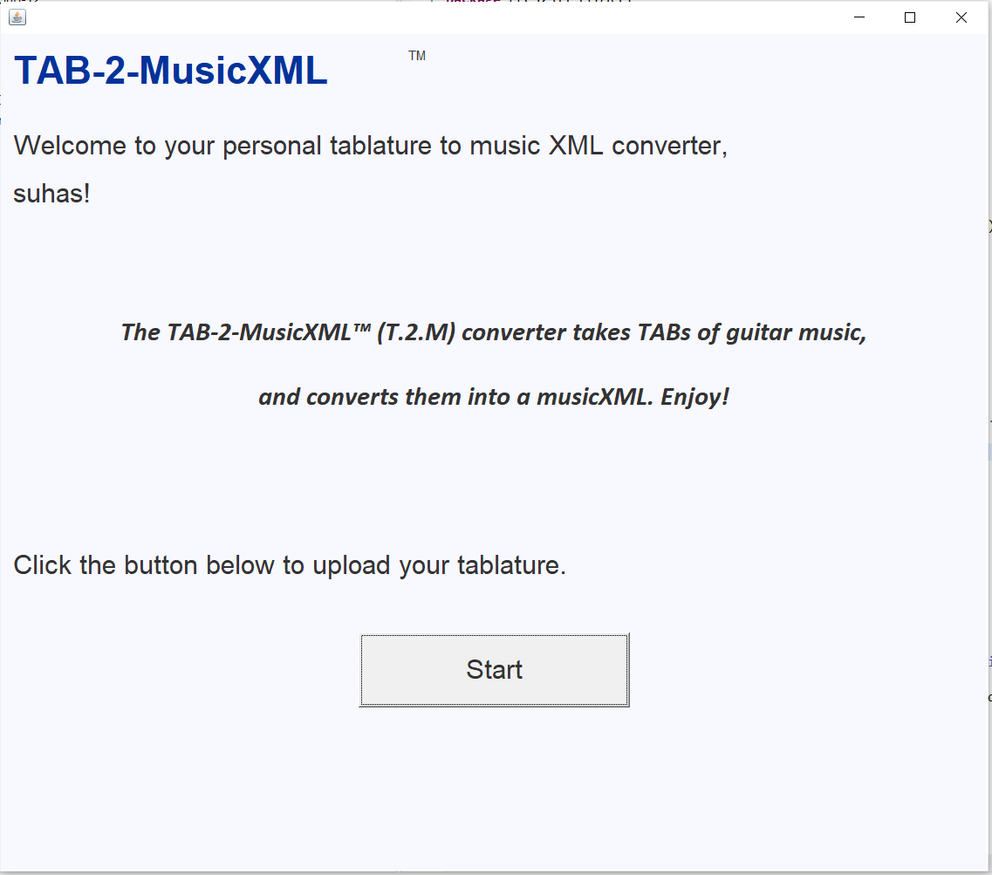

1. You will be presented with a window to enter the composer and title of the tab, these fields are optional. Once satisfied, please click next to continue.

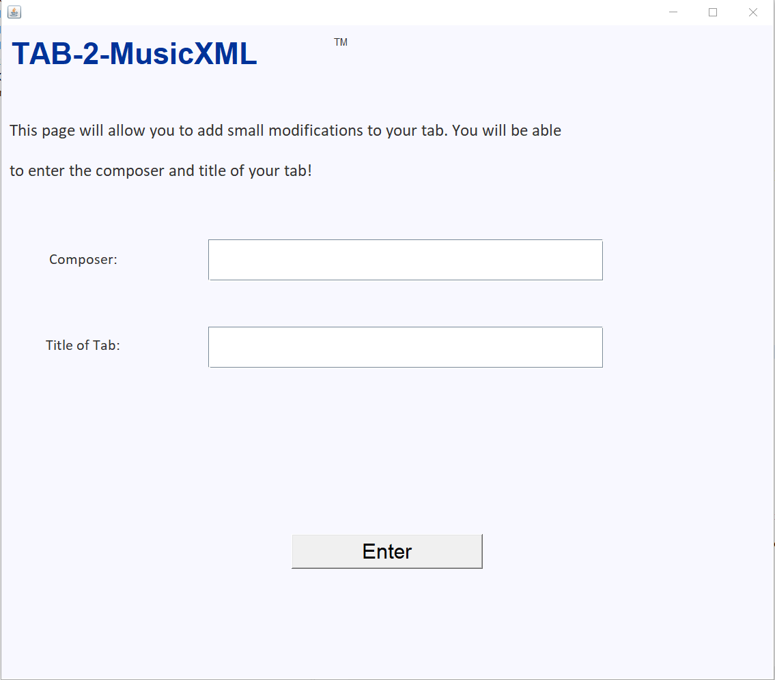

1. Currently the program only supports guitar tablatures that are pasted in text form or in “.txt” file format. Please ensure your input is in this format.

### 

1. *Case 1:* You have found a tab txt file and have it downloaded on your computer, click on the “Browse” button and navigate to the file location.
2. *Case 2:* You have found a “.txt” tablature online in text form and would like to copy and paste it, paste the desired tablature into the text editor directly.

There are two provided tabs inside the project folder under the “tabs” folder that you can use (And one in the Example section of this document). These tabs are the correct format the program looks for, if you received any errors with your tabs, please refer to these as references and attempt to match the format as best as possible.



1. Depending on which option you choose:
   1. If you want to upload the tablature “.txt” file, click on the “Browse” button to direct the application to where you have the “.txt” file stored in your computer. Once you’ve found it, the tablature will populate in the text field. Otherwise if you want to paste the tab, simply just paste it into the text field.
      1. *Case 1:* If you would like to make edits to the tab, simply just edit the text box. Once satisfied, click the “Enter” button to proceed.
      2. *Case 2:* If you are satisfied with the tab as is, click “Enter” to proceed.

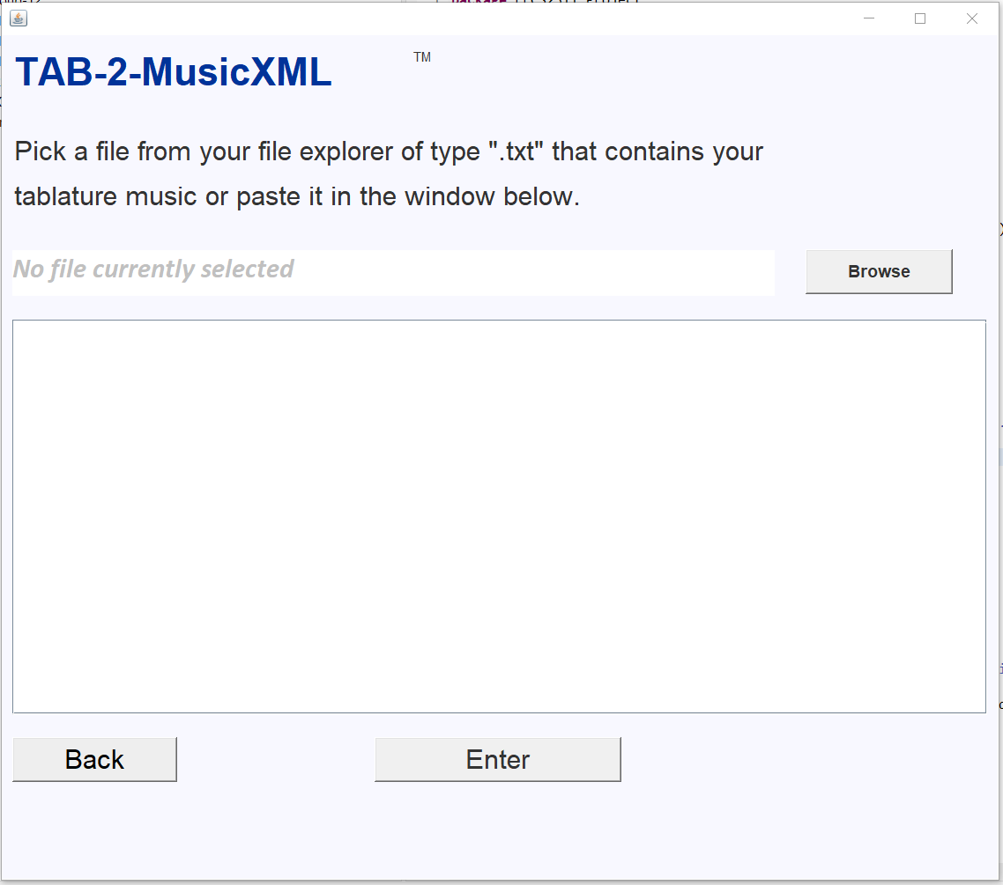

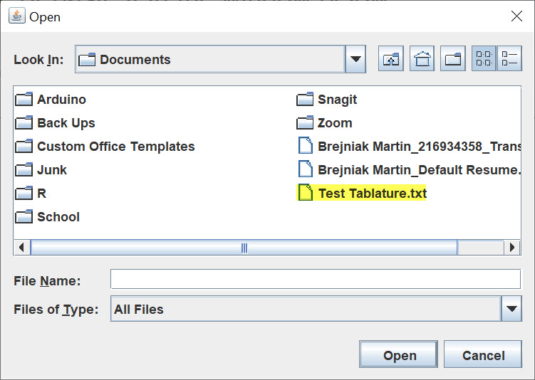

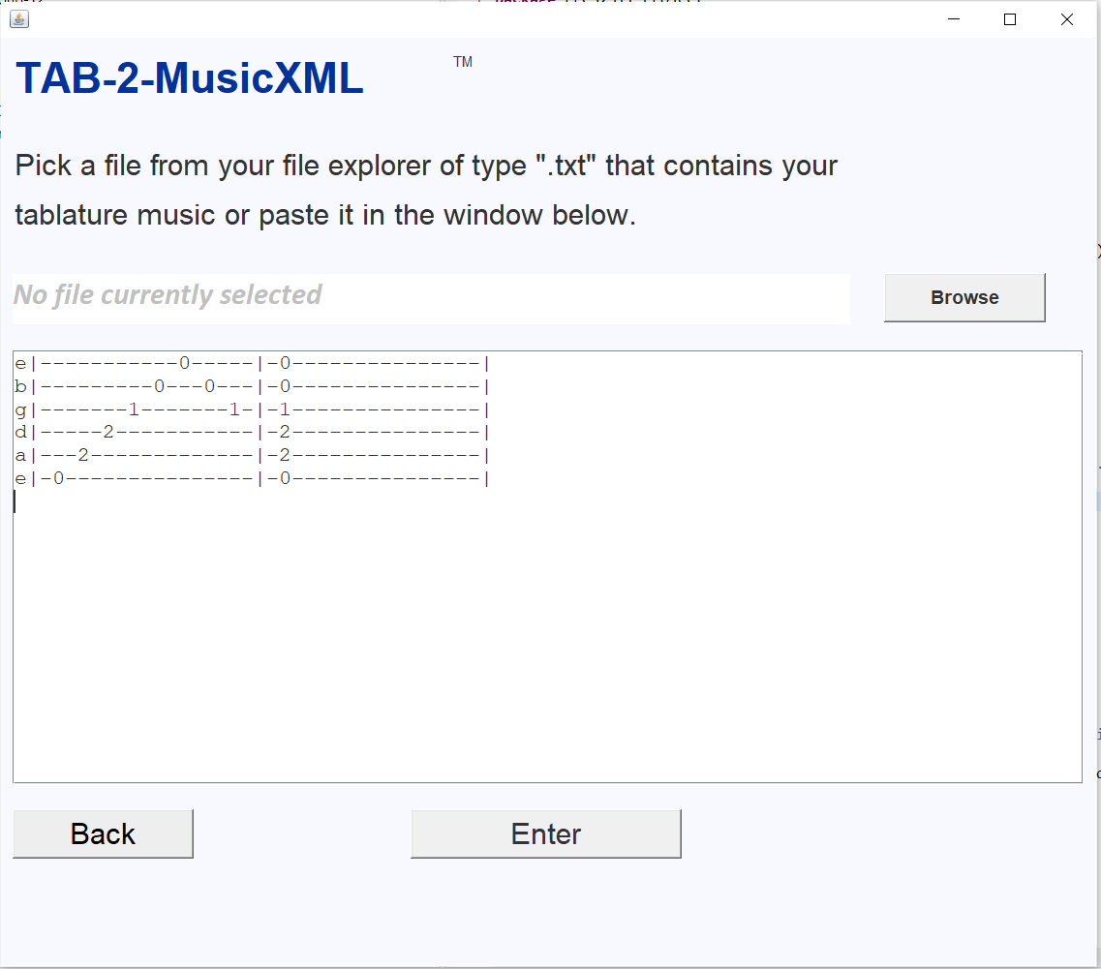

* 1. If you would like to go back to change the composer or title of the tab, click the “Back” button to go to the previous window and make any changes.

1. Once processed, a window will appear showing your musicXML output.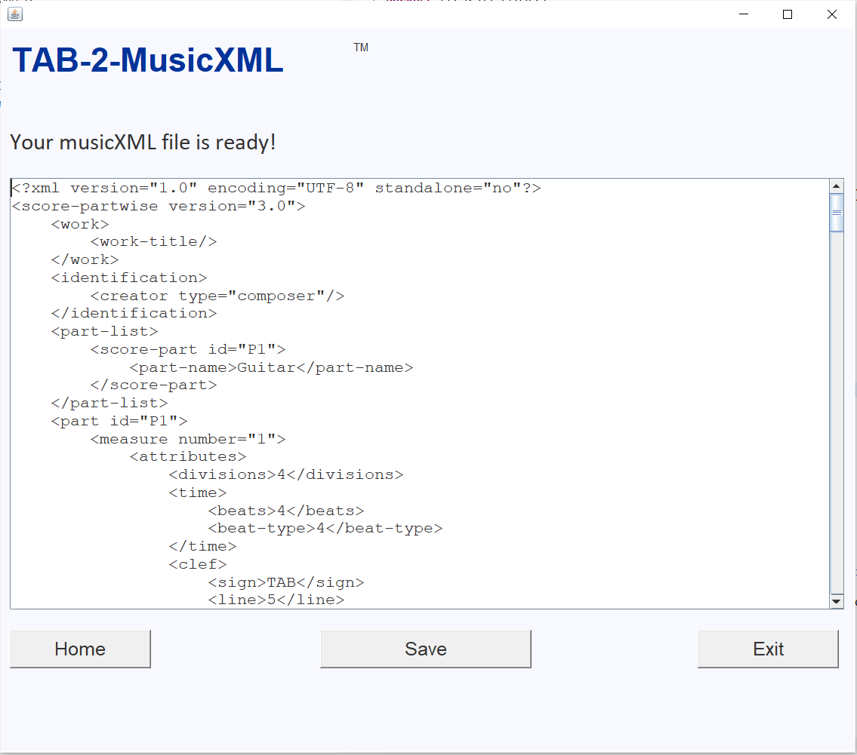
   * 1. *Case 1:* You would like to make edits to the output. Edit the output in the textbox and click “Save” to save the musicXML file.
     2. *Case 2:* You are satisfied with the output as is, click “Save” to proceed and navigate to the desired save location.
     3. *Case 3:* You would like to process another tab, click “Home” to be taken back to the start.

1. Once saved, the musicXML file will appear in the location you specified and it will automatically open on your computer.
2. The program will navigate back to the first window so you can process another tab if you wish.
3. Now that you have your musicXML file, you can view/play it on these websites:

<https://www.soundslice.com/musicxml-viewer/>

<https://opensheetmusicdisplay.github.io/demo/>

# 10. Sample Input Tablature

This is an example of a tablature you could paste into the software:

e|-----------0-----|-0---------------|

b|---------0---0---|-0---------------|

g|-------1-------1-|-1---------------|

d|-----2-----------|-2---------------|

a|---2-------------|-2---------------|

e|-0---------------|-0---------------|

The MusicXML file you receive should look like this (Click on the link): <https://wiki.eecs.yorku.ca/course_archive/2020-21/W/2311/_media/exampleemajor.musicxml.txt>

# 11. Troubleshooting

## 11.1) Error screen related issues

* 1. If you encounter the error screen, the most common issues are:
     1. The uploaded file is not in “.txt” format.
     2. The uploaded or pasted input is not a recognized tablature format.
     3. The program could not process your tablature.
     4. The tab must have the string letters in front of each string to process. Some tabs do not have those in front. Please add the string letters to the front of the line (such as “e” to the first line, “b” to the second line, etc.) so that it matches the example tablatures provided.

## 11.2) Input related issues

* 1. To troubleshoot these problems, please double check your inputs to see if they are in the correct format. Getting a fresh copy of the tablature, or trying another one could help.

# 12. Maintenance Information

The user should be vigilant about maintaining updates for program improvements and patch issues/bugs once the software has been installed. All future updates will be free, users can update their programs from the same installation link.

# 13. Uninstallation Instructions

The software program can be disposed of by right-clicking on the icon of the TAB-2-MusicXML™ and clicking “Delete” to remove the program. Then remove the project from your disc.

# 14. Technical Specifications

1. *Operating system:* Windows/Mac
2. *Platform:* Java
3. *Language:* English
4. Downloadable desktop application